TITLE OF THE CONTRIBUTION
N. Author1¹, N. Author2¹, N. Author3²,…, N. AuthorK³
¹Affiliation1,City1, Country1
²Affiliation2,City2, Country2
³Affiliation3,City3, Country3
name.author1@email.com

Here you should place the main text of the abstract. Text should be Arial 11pt, justified. References in text should be indicated within parentheses [1]. Figures and tables should be embedded in the text and a caption should be provided (Arial 9 pt).

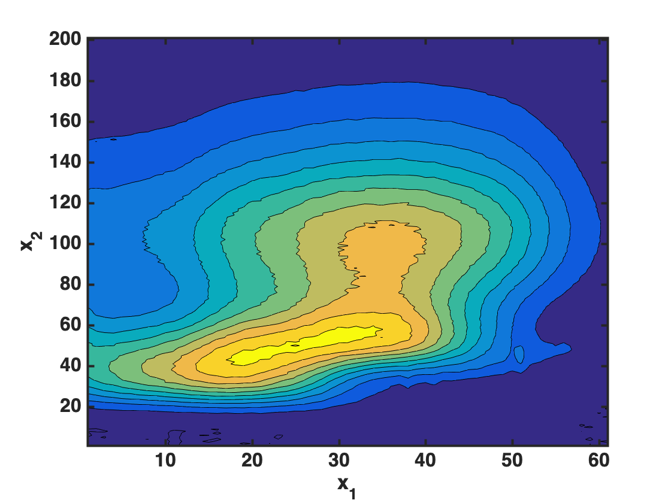
Figure 1 – Example of a Figure

Abstract should not exceed one page, references included.

References
[1] N. Surname1, N. Surname2, …, N. SurnameK, J. Name Abbr. vol (year) pages.

